JavaScript Can Change HTML Content

One of many JavaScript HTML methods is getElementById().

The example below "finds" an HTML element (with id="demo"), and changes the element content (innerHTML) to "Hello JavaScript":

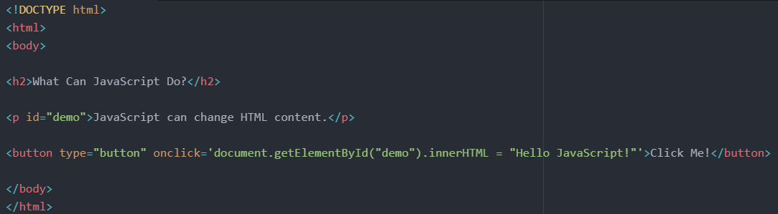

## JavaScript Can Change HTML Attribute Values

In this example JavaScript changes the value of the src (source) attribute of an <img> tag:

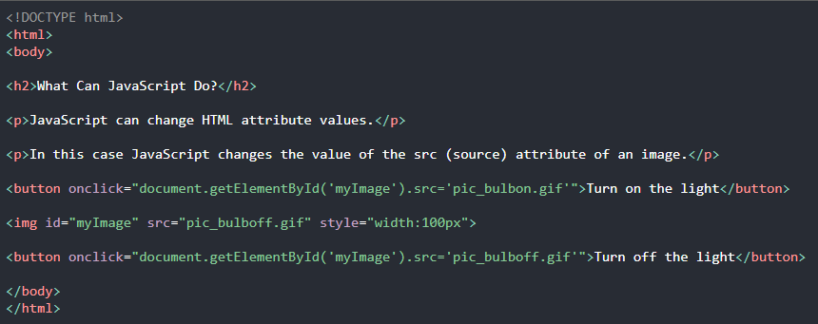

## JavaScript Can Change HTML Styles (CSS)

Changing the style of an HTML element, is a variant of changing an HTML attribute:

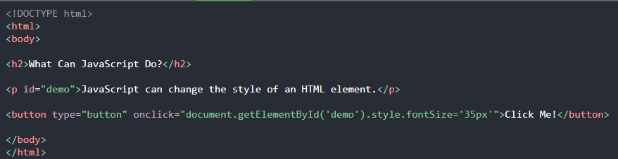

## JavaScript Can Hide HTML Elements

Hiding HTML elements can be done by changing the display style:

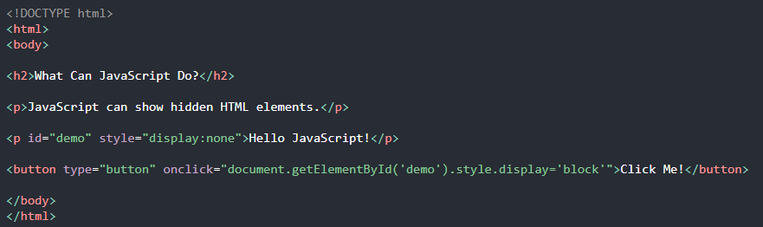

# **JavaScript Where To**

## The <script> Tag

In HTML, JavaScript code is inserted between <script> and </script> tags.

## JavaScript Functions and Events

A JavaScript function is a block of JavaScript code, that can be executed when "called" for.

For example, a function can be called when an **event** occurs, like when the user clicks a button.

## External JavaScript

Scripts can also be placed in external files:

External scripts are practical when the same code is used in many different web pages.

JavaScript files have the file extension **.js**.

To use an external script, put the name of the script file in the src (source) attribute of a <script> tag:



## External References

External scripts can be referenced with a full URL or with a path relative to the current web page.

This example uses a full URL to link to a script:



## avaScript Display Possibilities

JavaScript can "display" data in different ways:

* Writing into an HTML element, using innerHTML.
* Writing into the HTML output using document.write().
* Writing into an alert box, using window.alert().
* Writing into the browser console, using console.log().

## Using innerHTML

To access an HTML element, JavaScript can use the document.getElementById(id) method.

The id attribute defines the HTML element. The innerHTML property defines the HTML content:

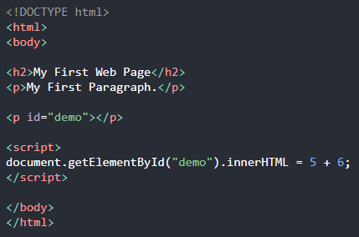

## JavaScript Print

JavaScript does not have any print object or print methods.

You cannot access output devices from JavaScript.

The only exception is that you can call the window.print() method in the browser to print the content of the current window.



## JavaScript Values

The JavaScript syntax defines two types of values:

* Fixed values
* Variable values

Fixed values are called **Literals**.

Variable values are called **Variables**.

## One Statement, Many Variables

You can declare many variables in one statement.

Start the statement with var and separate the variables by **comma**:



Using the dollar sign is not very common in JavaScript, but professional programmers often use it as an alias for the main function in a JavaScript library.

In the JavaScript library jQuery, for instance, the main function $ is used to select HTML elements. In jQuery $("p"); means "select all p elements".

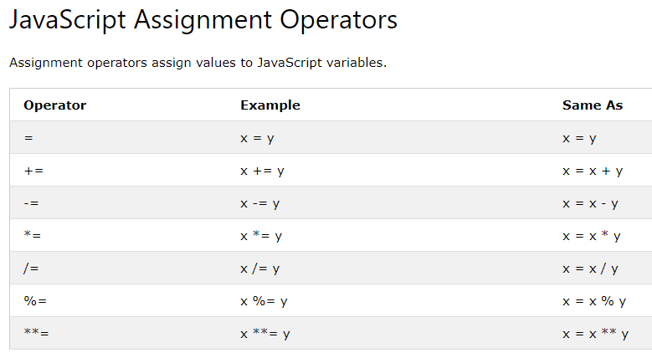

JavaScript Type Operators

|  |  |
| --- | --- |
| **Operator** | **Description** |
| typeof | Returns the type of a variable |
| instanceof | Returns true if an object is an instance of an object type |